**Final Requirement 2: Design Stage**

* This is the landing page of our advocacy website.

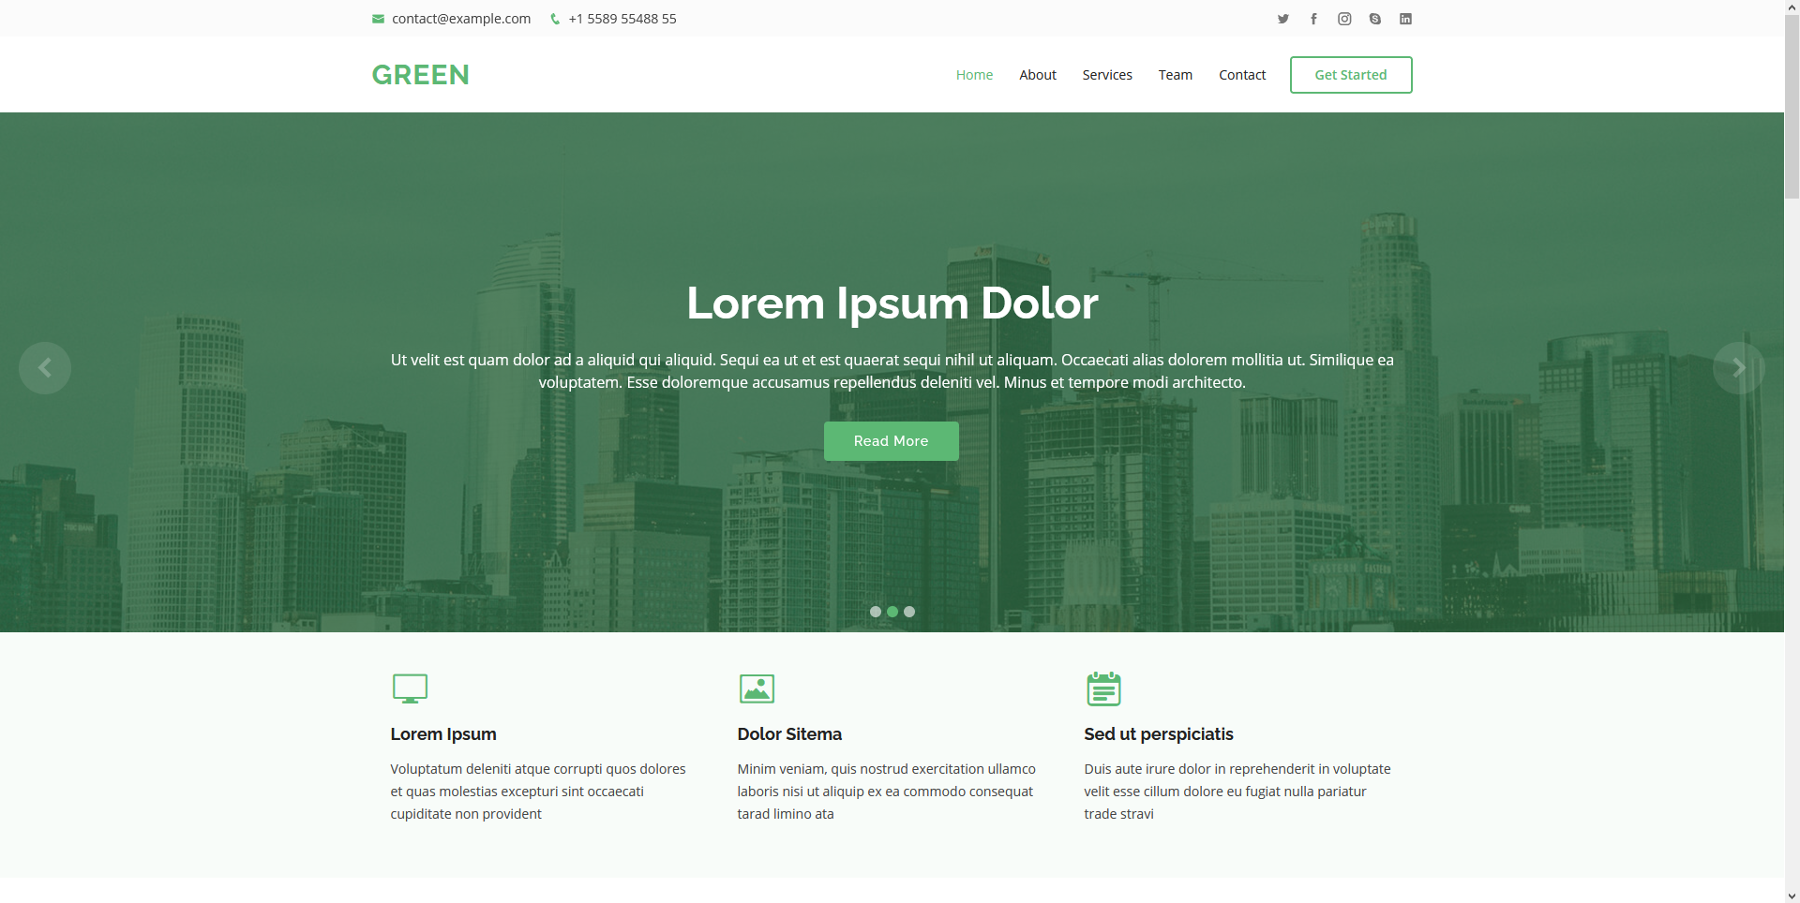

* The about section where you will get to know me about our advocacy about environmental awareness.

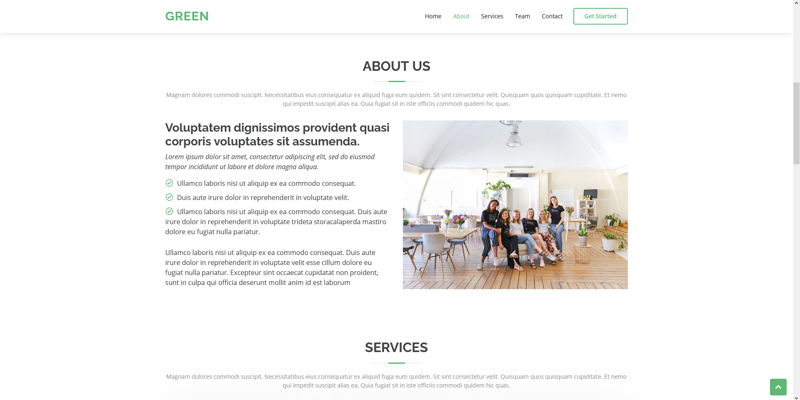

* The services that we provide are found in the services section.

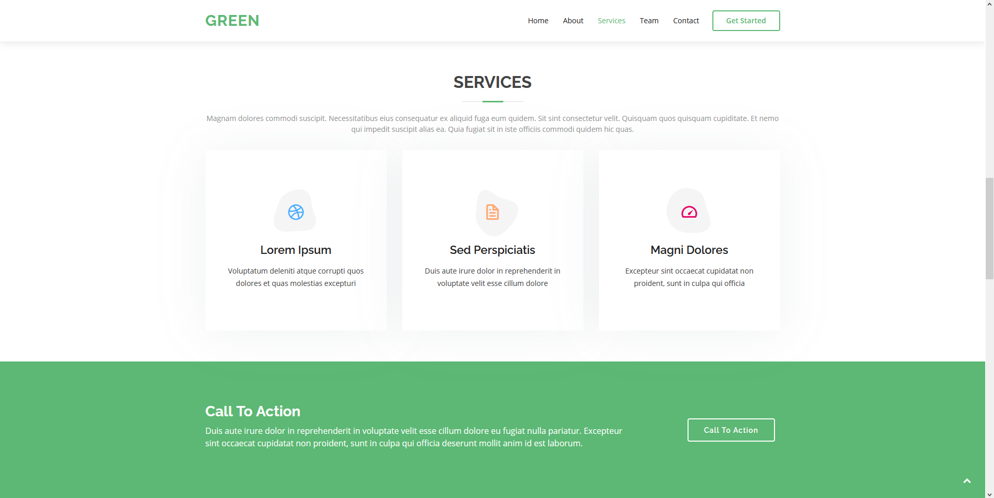

* This is the team section where you will get to know the people behind the advocacy.

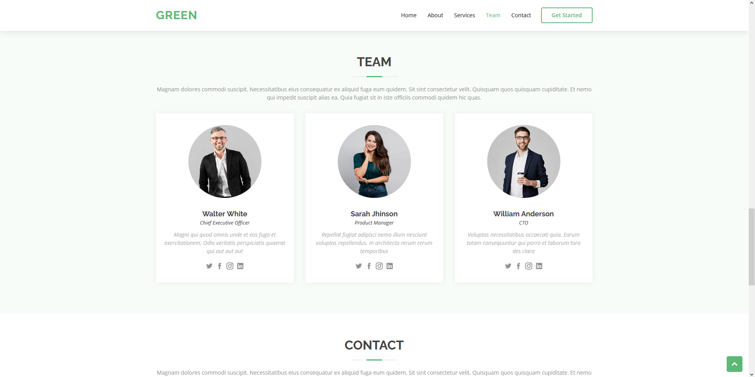

* The last section of our advocacy website is the contact section. This is where you can get in touch with us by sending a message.

